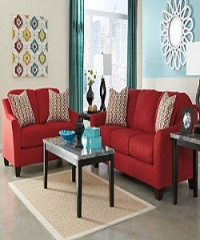

Sofa sets

$91.50

Availability: In stock

Description

The light and fresh design, tapered legs, and oatmeal tweed upholstery of this seating collection create a stylish look that embraces vintage flair and modern living. Complete your living room decor with these chic seating options. Matte Red Color.